Feel the Beat
Introduction
The heart is a powerful muscle, pumping blood and oxygen all around our body and yet we use this amazing organ to describe many other experiences and feelings too. When people say that their heart is broken, they’re really saying that they feel very sad. Or if they place their hand over their heart, they want you to know that their words are absolutely true. Almost everyone has drawn a picture of a heart to say that they love someone.
When we are frightened, nervous or excited our hearts beat really fast and loud – sometimes we even hear our hearts beating inside our ears. People frequently say that their heart skipped a beat, when they get a shock or surprise. Your brain may process our thoughts and emotions, but our hearts are clearly responding to our feelings.
Muscle Power
Clench your fist and put it slightly to the left of the middle of your chest. That’s about the size and location of your heart inside the body. Now squeeze your fist really tightly and then release it. That’s how the heart muscle works - like a pump – filling with blood and then contracting to push the blood throughout your body. Your heart is one of the most important muscles in the body, working without a break. Together with the lungs and blood vessels, your heart carries oxygen and nutrients to all your cells and then carries carbon dioxide and waste products away.
The left side of the heart pumps blood rich with oxygen from the lungs. At the same time, the right side of the heart is busy receiving all the blood that’s returning from other parts of the body; having delivered oxygen to the muscles and organ systems. This blood gets pumped back to the lungs where it is oxygenated and ready to return to the body.
Heart Beat
A complete cycle of pumping blood around our body is called a heartbeat. When we are at rest, our heart beats between 60 and 80 times per minute. Even when we are asleep, our heart is hard at work. Your heart will beat about 3 billion times during your lifetime. Our heart rate or pulse is the number of times that the heart beats during a minute. Heart rate is affected by many factors including age, gender, physical fitness and activity level.
Measurements to be taken
In this investigation, students will record heart rate before and after exercise using an ear clip sensor. This sensor measures how our ear lobe (or finger) changes its light transparency as blood flows through it.
Materials needed
- Mini with Heart Rate clip
- Feel the Beat data sheet
Mini Set Up
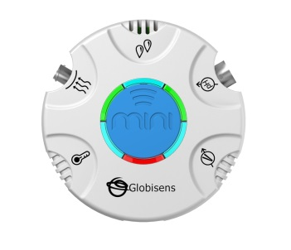
For this experiment you will setup the Mini from the GlobiLab software menu. Use the directions in Getting to Know the Mini if you need assistance.
- Sensor Selection - select the Ambient Temperature
- Sampling Rate - 25/second
- Number of Samples - select 2000
When you hit the Run button, the green LED lights will circle indicating that the Mini is in Manual data collection mode. Keep in mind that the Heart Rate sensor will take about 2 seconds to establish the heart rate.
Experiment Set Up
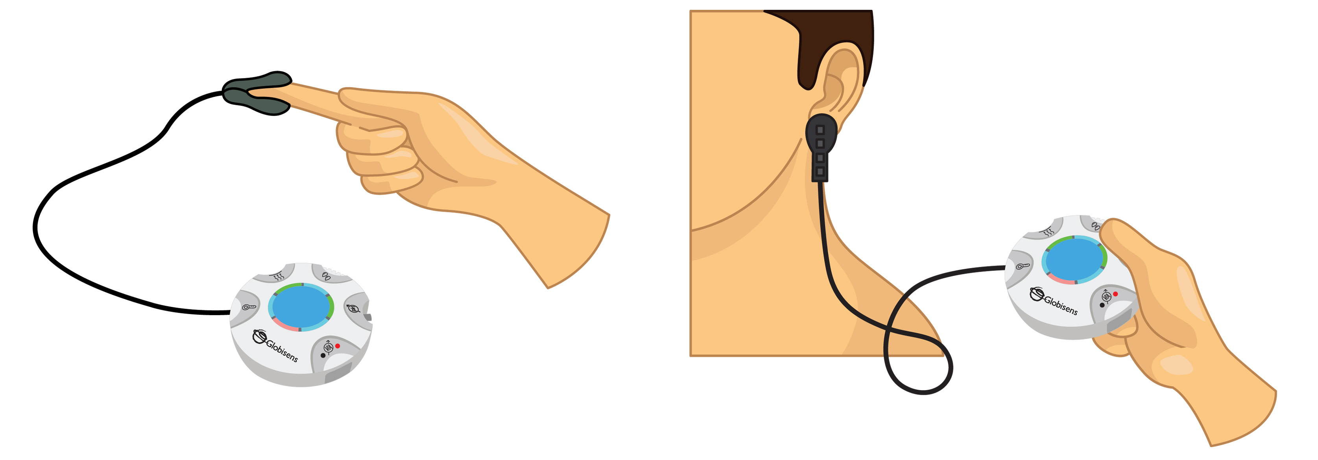
Connect the ear clip to the input located directly under the External Temperature icon. Make sure that the ear clip is well positioned on your finger or ear lobe as shown.

Experiment Procedure
- Click on the Start button to begin the data collection. Sit quietly for 20 seconds and then begin recording your resting heart rate. The Heart Rate sensor is very sensitive to motion so be sure to sit very still while taking your heart rate.
- Use the magnifying tool to zoom in on a 15 second section from the middle of your collection. Use the marker tool to mark the beginning and the end of this section. Count the number of heart beats during this 15 second period and multiply that number by 4 to get your resting heart rate. Record your results on the data sheet. Your graph will look something like this
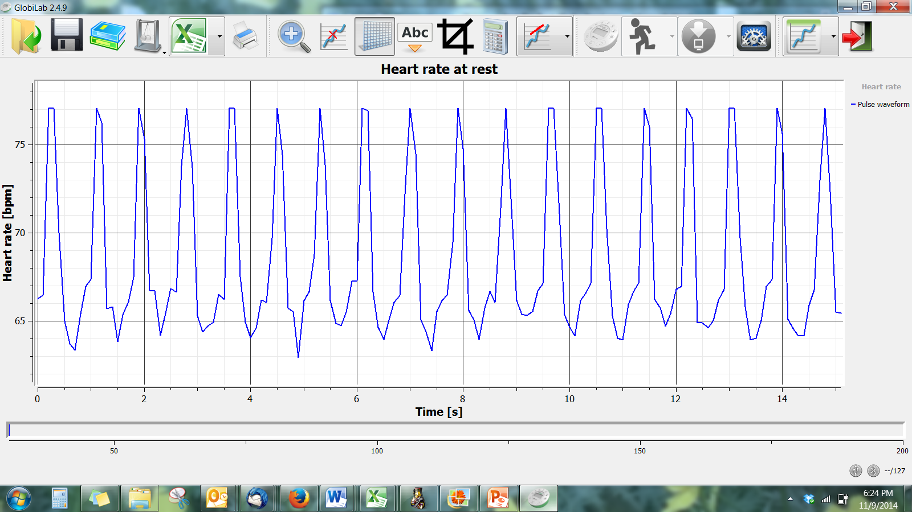
- Exercise vigorously for 2 minutes – doing jumping jacks or running in place. (Sing the alphabet *and* Happy Birthday twice each for an approximately 2 minute duration).
- Repeat the data collection after the exercise. Again, remember that the Heart Rate sensor is very sensitive to motion so be sure to sit very still while taking your heart rate. Your graph will look something like this:
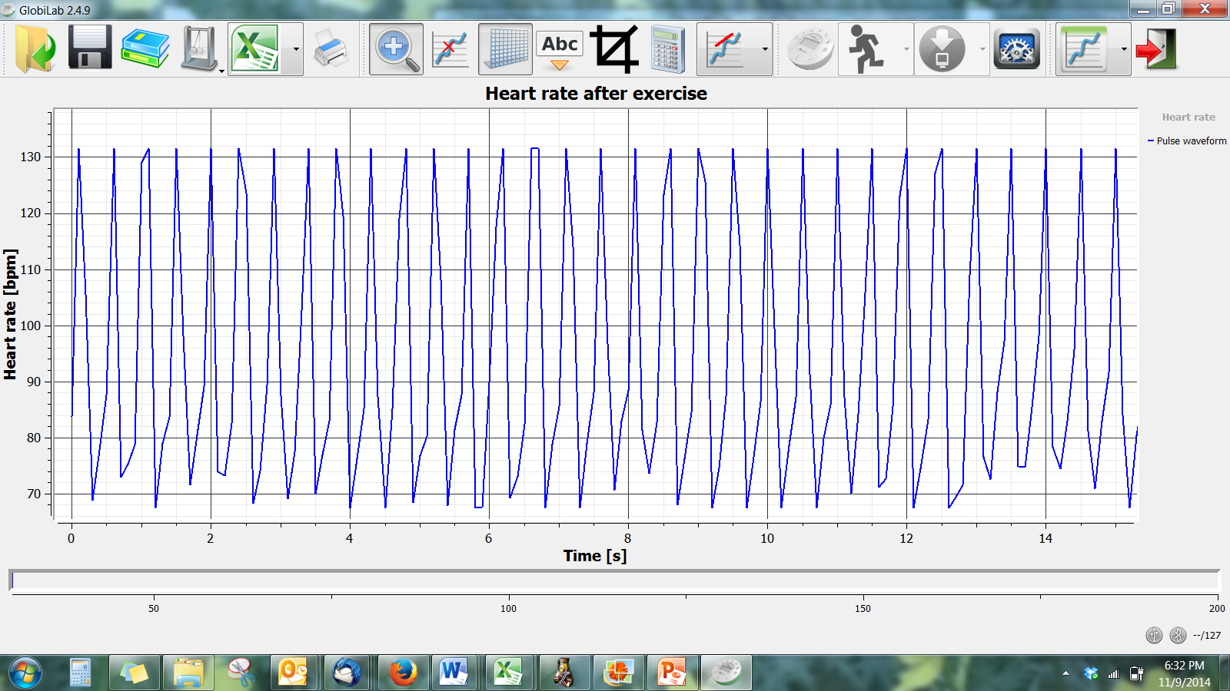
- Use the magnifying tool to zoom in on a 15 second section from the middle of your collection. Use the marker tool to mark the beginning and the end of this section. Count the number of heart beats during this 15 second period and multiply that number by 4 to get your resting heart rate. Record your results on the data sheet.
- Zoom in on the next 15 second section of the data collection, mark the beginning and end and count the heart rate during this 20 second period.
- Continue moving across the graph, zooming in on 15 second sections at a time and counting the heart rate in each 15 second period.
Questions & Observations
- What was your heart rate at rest?
- What was your heart rate immediately after exercise?
- What did you notice about your heart rate in each successive 20 second period after exercise?
- How much time did it take for your heart beat to decrease to below 90 bpm?
- What does it say about your physical condition if your heart rate returned to your resting heart rate in:
  - 60 seconds or less
  - 61 to 80 seconds
  - More than 2 minutes
- What prediction would you make about the resting heart rate of a professional athlete? What do you predict about how fast their heart rate would return to the resting rate?
- When during the day do you think your heart rate would be the lowest? The highest?
Extension Activity
- While recording your heart rate at rest, try to relax yourself and reduce your heart rate.
- Check your heart rate after lunch and compare it to your initial resting heart rate. Is it higher or lower or the same? Why do think this is?
- Try to compare heart rate when measured in your ear lobe and your finger. How does it compare?
- Heart rate is also a good indicator of when we feel frightened or nervous. Try to create an activity that demonstrates a change in heart rate based on emotion.

Feel the Beat

Resting Heart Rate
Heart rate 0-15 seconds after exercise
Heart rate 15-30 seconds after exercise
Heart rate 30-45 seconds after exercise
Heart rate 45-60 seconds after exercise
Heart rate 60-75 seconds
after exercise
Heart rate 75-90 seconds
after exercise
Heart rate 90-120 seconds
after exercise
NGSS Standards
Performance Expectations
Construct an argument that plants and animals have internal and external structures that function to support survival, growth, behavior, and reproduction. 4-LS1-1

Science and Engineering Practices
Construct an argument with evidence, data, and/or a model.

Disciplinary Core Ideas
LS1.A: Structure and Function. Plants and animals have both internal and external structures that serve various functions in growth, survival, behavior, and reproduction.

Crosscutting Concepts
A system can be described in terms of its components and their interactions.

Common Core State Standards Connections
ELA/Literacy
W.4.1 - Write opinion pieces on topics or texts, supporting a point of view with reasons and information.

Florida Next Generation Standards Correlation
- SC.4.N.A - Scientific inquiry is a multifaceted activity; the processes of science include the formulation of scientifically investigable questions, construction of investigations into those questions, the collection of appropriate data, the evaluation of the meaning of those data, and the communication of this evaluation.
- SC.4.N.1.2 - Compare the observations made by different groups using the same tools and seek reasons to explain the differences across groups.
- SC.4.N.1.4 - Attempt reasonable answers to scientific questions and cite evidence in support.
- SC.4.N.1.5 - Compare the methods and results of investigations done by other classmates.
- SC.4.N.1.6 – Keep records that describe observations made, carefully distinguishing actual observations from ideas and inferences about the observations.
- SC.4.N.1.7 - Recognize and explain that scientists base their explanations on evidence.
- SC.4.N.1.8 - Recognize that science involves creativity in designing experiments.

Language Arts
- LAFS.4.SL.1.1– Participate in collaborative conversations with diverse partners about grade 1 topics and texts with peers and adults in small & larger groups.
- LAFS.4.RI.1.3 – Describe the connection between a series of historical events scientific ideas or concepts or steps on technical procedures in a text.

Mathematics
- MACC.4.MP.5: Use appropriate tools strategically.
- MACC.4.MP.8: Look for and express regularity in repeated reasoning.

Physical Education
- PE.4.C.2.3 - Use technology to gather information about performance.
- PE.4.L.4.3 - Maintain heart rate within the target heart rate zone for a specified length of time during
an aerobic activity.

